Name: Yahya Alhinai

1. **AD1CON2**=0x412 = 0b0000010000010010
   1. **BUFM** = 1 🡪 Buffer configured as two 8-word buffers
   2. **SMPI** = 0100 🡪 Interrupts at the completion of conversion for each 5nd sample/convert sequence
   3. **CSCNA** = 1 🡪 Scan inputs selected by the AD1CSSL register

**AD1CHS** = 0x0002 = 0b10 = 2 🡪 A/D Input Channel Select Register is 2 🡪 Channel 0 positive input is AN2

**AD1CSSL** = 0x1001 = 0b1000000000001 🡪 A/D Input Scan Select Registers 🡪 AN0 and AN12 analog channel are selected for sequential scanning

* When the program is executed for a long time, each buffer will hold an input from AN0 or AN8 alternatively for 5 registers in each of the 8-word buffer. It is going to be pressing one 8-word buffer while it is collecting inputs in the other 8-word buffer. So it’s going to be like:
* First 8-word buffer:

ADC1BUF0 = AN0

ADC1BUF1 = AN12

ADC1BUF2 = AN0

ADC1BUF3 = AN12

ADC1BUF4 = AN0

* Second 8-word buffer:

ADC1BUF8 = AN12

ADC1BUF9 = AN0

ADC1BUF10 = AN12

ADC1BUF11 = AN0

ADC1BUF12 = AN12

1. **2.345 =** 0b10.010110000 with quantization error of $0.64*{10}^{-9}$

0b10.010110000 = 2.34375

Error = |2.34375 - 2.345 | =

**1.891 =** 0b01.110111000 with quantization error of $0.192*{10}^{-9}$

0b01.110111000 = 1.890625

Error = |1.890625 - 1.891 | =

**3.792 =** 0b11.110010101 with quantization error of $0.504*{10}^{-9}$

0b11.110010101 = 3.791015625

Error = |3.791015625 - 3.792 | =

(**1.891 * 3.792**) = 0b111.001010101

0b111.001010101 = 7.166015625

Error = |7.166015625 - 7.170672 | = 0.004656375

**2.345** + (**1.891 * 3.792**) = 0b1001.100001000

0b1001.100000101 = 9.509765625

Error = |9.509765625 - 9.515672 | = 0.005906375

Fcy = 16MHz

TSAMP ≥ 1us.

Samples = 20,000/second

Time for each sample = 50us/sample

S = SAMC, A = ADCS + 1

Total Sample time = [ 12 * 62.5ns * A + S * 62.5ns * A] = 50us

A = (50 us)/(12 * 62.5ns + S * 62.5ns)

Solve for A and S:

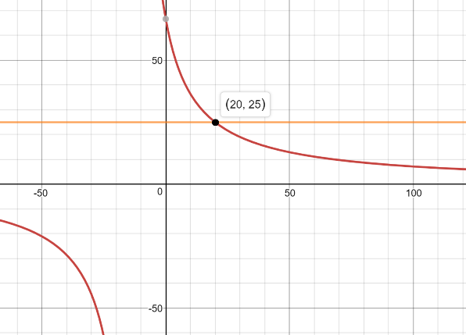

SAMC = 20

ADCS = 24

Tsamp = 20 * 25 * 62.5 ns = 31.25 us

Total Sample time = [ 12 * 62.5ns * 25 + 20 * 62.5ns * 25] = 50us

Frequency = 4 MHz 🡪 Tcy = 250 ns

250 ns > 75 ns 🡪 ADCS = 0 🡪 Time = 1 * Tcy = 250 ns

Tsamp cutoff = $\left\lceil \frac{3.2 micro}{250 nano}\right\rceil = \left\lceil 12.8\right\rceil$ = 13 🡪 SAMC = 13

Actual Tad = 250 ns

Actual Tsamp time = 13 * Tad = 13 * 250 ns = 3.25 micro second

Sampling time = (13 + 12) * 250 ns = 6.25 micro second

Sampling rate = $\frac{1}{6.25 micro}$ = 160 KHz